**WORKSHEET 2**

**MACHINE LEARNING**

**22PW28**

**PRATHOSHINI DEVI M B**

**PPT PROBLEM SOLUTION**

**import numpy as np**

**x=np.array([[1,4.0],**

**[1,4.5],**

**[1,5.0],**

**[1,5.5],**

**[1,6.0],**

**[1,6.5],**

**[1,7.0]])**

**y=np.array([[33],[42],[45],[51],[53],[61],[62]])**

**print(y)**

**XtransposeX=np.dot(np.transpose(x),x)**

**XtransposeY=np.dot(np.transpose(x),y)**

**b=np.dot(np.linalg.inv(XtransposeX),XtransposeY)**

**print(b)**

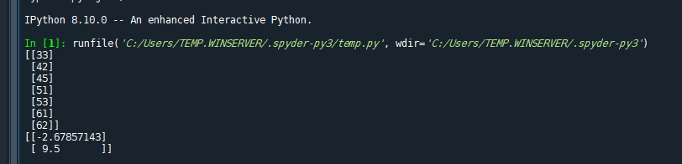

CHANGING X

**import numpy as np**

**x=np.array([[1,45,48],**

**[1,46,49],**

**[1,27,30],**

**[1,58,41],**

**[1,52,2],**

**[1,42,18],**

**[1,25,26]])**

**y=np.array([[33],[42],[45],[51],[53],[61],[62]])**

**print(y)**

**XtransposeX=np.dot(np.transpose(x),x)**

**XtransposeY=np.dot(np.transpose(x),y)**

**b=np.dot(np.linalg.inv(XtransposeX),XtransposeY)**

**print(b)**

OUTPUT:

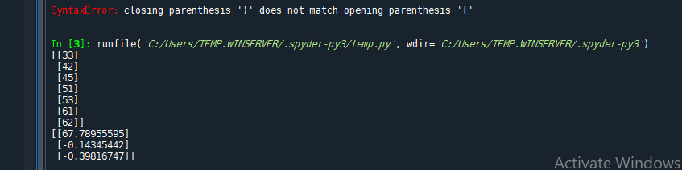

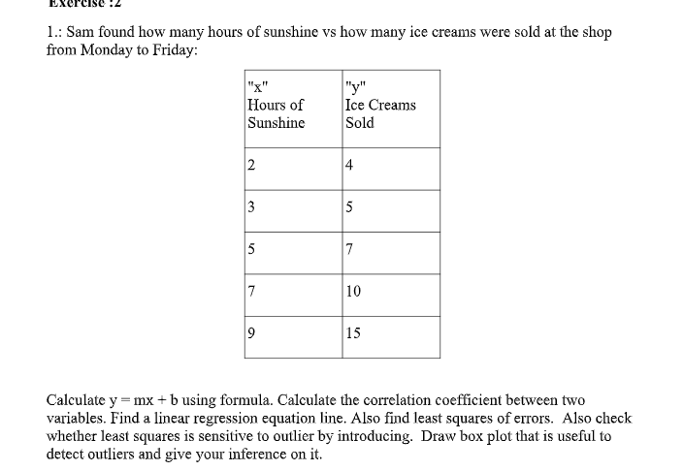

import numpy as np

import matplotlib.pyplot as plt

import seaborn as sns

# Original data

x = np.array([[1, 2],

[1, 3],

[1, 5],

[1, 7],

[1, 9]])

y = np.array([[4], [5], [7], [10], [15]])

Y = np.array([4, 5, 7, 10, 15])

X = np.array([2, 3, 5, 7, 9])

# Linear regression using matrix operations

XtransposeX = np.dot(np.transpose(x), x)

Xtransposey = np.dot(np.transpose(x), y)

b = np.dot(np.linalg.inv(XtransposeX), Xtransposey)

print(b)

print('THE LINEAR REGRESSION EQUATION IS y=', b[0], '+', b[1], 'x')

# Correlation coefficient

r = np.corrcoef(X, Y)

print(r[0, 1], ' is the correlation coefficient')

# Linear regression using formula

sum_x = sum(X)

sum_y = sum(Y)

sum_xy = sum(X * Y)

sum_xsq = sum(X ** 2)

b_formula = ((5 * sum_xy) - (sum_x * sum_y)) / ((5 * sum_xsq) - (sum_x ** 2))

a_formula = (sum_y - (b_formula * sum_x)) / 5

print(b_formula)

print(a_formula)

print('THE LINEAR REGRESSION EQUATION IS y=', a_formula, '+', b_formula, 'x')

# Mean Squared Error (MSE)

error = 0

for i in range(5):

error += (Y[i] - (a_formula + b_formula * X[i])) ** 2

print('MSE', error)

# Introduce an outlier

Y_outlier = np.array([4, 5, 7, 10, 50]) # Changed the last value to 50 to introduce an outlier

sum_y_outlier = sum(Y_outlier)

sum_xy_outlier = sum(X * Y_outlier)

b_formula_outlier = ((5 * sum_xy_outlier) - (sum_x * sum_y_outlier)) / ((5 * sum_xsq) - (sum_x ** 2))

a_formula_outlier = (sum_y_outlier - (b_formula_outlier * sum_x)) / 5

print('With outlier:')

print(b_formula_outlier)

print(a_formula_outlier)

print('THE LINEAR REGRESSION EQUATION IS y=', a_formula_outlier, '+', b_formula_outlier, 'x')

# Mean Squared Error (MSE) with outlier

error_outlier = 0

for i in range(5):

error_outlier += (Y_outlier[i] - (a_formula_outlier + b_formula_outlier * X[i])) ** 2

print('MSE with outlier', error_outlier)

# Box plot to detect outliers

plt.figure(figsize=(10, 6))

sns.boxplot(data=[Y, Y_outlier], palette="Set3")

plt.xticks([0, 1], ['Original Data', 'Data with Outlier'])

plt.title('Box Plot to Detect Outliers')

plt.ylabel('Values')

plt.show()

**OUTPUT:**

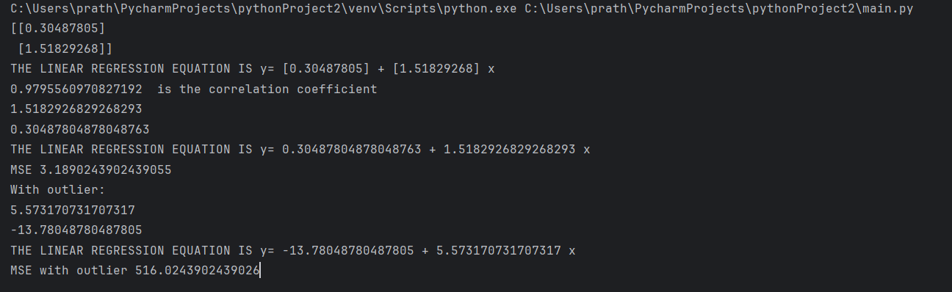

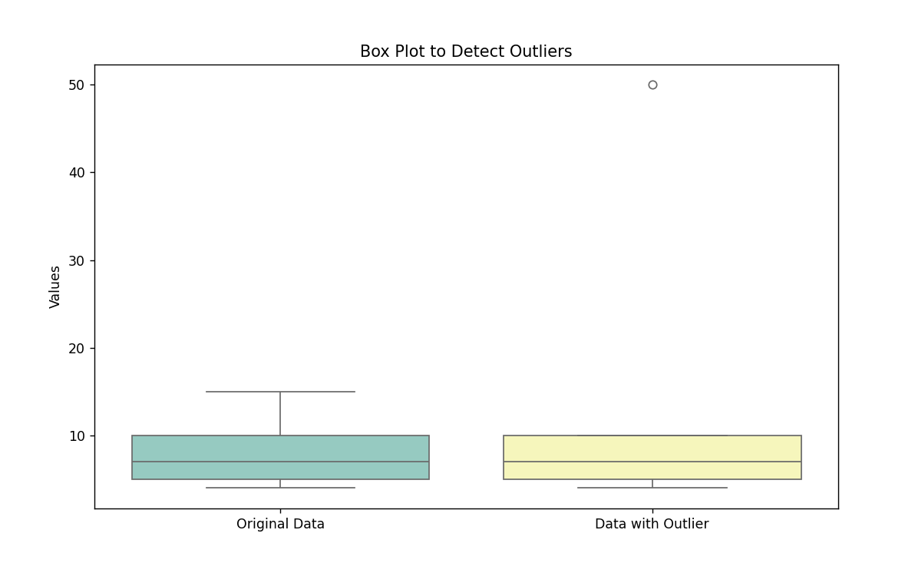

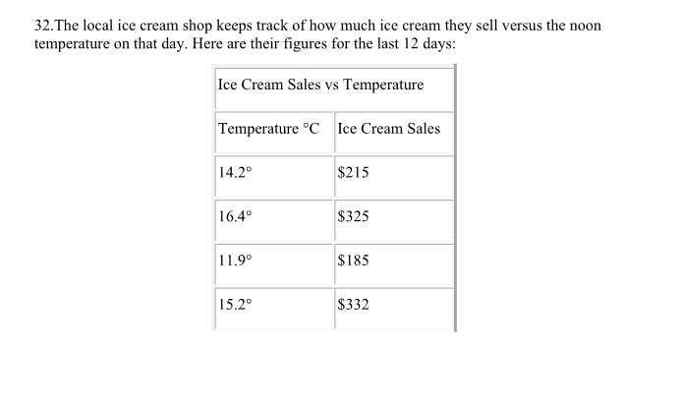

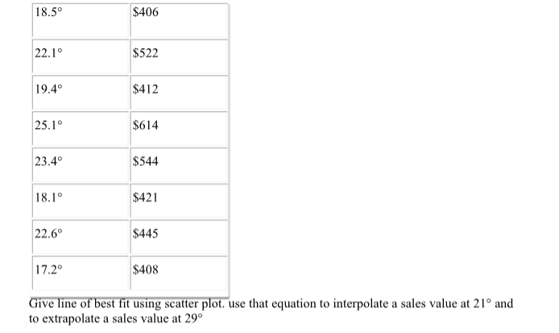

**import numpy as np**

**import pandas as pd**

**import matplotlib.pyplot as plt**

**import seaborn as sns**

**from sklearn.linear_model import LinearRegression**

**data={**

**'Temperature(C)':[14.2,16.4,11.9,15.2,18.5,22.1,19.4,25.1,23.4,18.1,22.6,17.2],**

**'Ice cream sales($)':[215,325,185,332,406,522,412,614,544,421,445,408]}**

**df=pd.DataFrame(data)**

**x=df[['Temperature(C)']]**

**y=df['Ice cream sales($)']**

**print(x)**

**print(y)**

**best_fit_line=LinearRegression().fit(x,y)**

**plt.scatter(x,y)**

**plt.plot(x,best_fit_line.predict(x))**

**plt.legend()**

**plt.show()**

**interpolate=21**

**interpolate_result=best_fit_line.predict([[interpolate]])**

**print(f"The value of interpolation of 21 : {interpolate_result[0]:.2f}")**

**extrapolate=29**

**extrapolate_result=best_fit_line.predict([[extrapolate]])**

**print(f"The value of extrapolation of 29 : {extrapolate_result[0]:.2f}")**

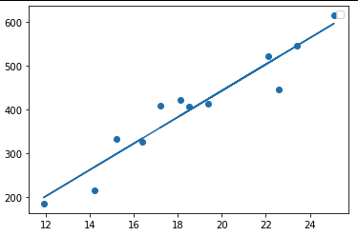

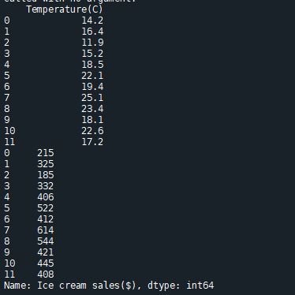



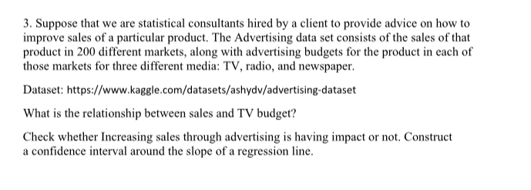

import pandas as pd

import numpy as np

from scipy import stats

import matplotlib.pyplot as plt

from sklearn.linear_model import LinearRegression

df = pd.read_csv(r"C:\Users\prath\Downloads\archive\advertising.csv")

print(df.columns)

tv_col = 'TV'

sales_col = 'Sales'

correlation = df[tv_col].corr(df[sales_col])

print(f"Correlation coefficient between sales and TV budget: {correlation:.2f}")

X = df[[tv_col]]

y = df[sales_col]

reg = LinearRegression().fit(X, y)

plt.figure(figsize=(10, 6))

plt.scatter(X, y, color='blue', label='Data points')

plt.plot(X, reg.predict(X), color='red', label='Line of best fit')

plt.xlabel('TV Budget ($)')

plt.ylabel('Sales ($)')

plt.title('Sales vs. TV Budget')

plt.legend()

plt.show()

print(f"For every $1 increase in TV budget, sales are expected to increase by ${m:.2f}")

confidence_level = 0.95

t_value = stats.t.ppf((1 + confidence_level) / 2, len(X) - 2)

margin_error = t_value * np.std(y) / np.sqrt(len(X))

print(f"Confidence interval for the slope: ({m - margin_error:.2f}, {m + margin_error:.2f})")

if m - margin_error > 0 and m + margin_error > 0:

print("Increasing sales through advertising has a positive impact on sales.")

elif m - margin_error < 0 and m + margin_error < 0:

print("Increasing sales through advertising has a negative impact on sales.")

else:

print("We are not confident that increasing sales through advertising has a significant impact on sales.")

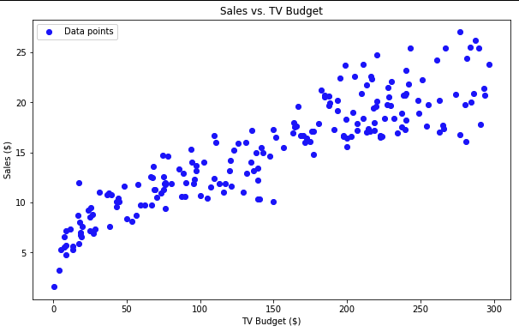

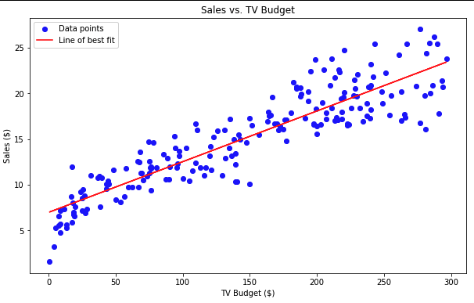

**Correlation coefficient between sales and TV budget: 0.90**

**Line of best fit equation: y = 0.06x + 6.97**

**For every $1 increase in TV budget, sales are expected to increase by $0.06**

**Index(['TV', 'Radio', 'Newspaper', 'Sales'], dtype='object')**

**Correlation coefficient between sales and TV budget: 0.90**